TIC TAC TOE GAME WEBSITE

- Overview Of Project
This is an Tic Tac Toe project game. It is made up of HTML, CSS, and JavaScript. This game has Contains RegistrationPage, LoginPage, GamePlayPage, and LeaderBoardPage as well. Then, User Play against bot. The game is designed to be interactive and user-friendly, and use of local storage to save user data.

- Features
User Registration: User can open account by adding their personal details like name, student-id, Email-id, and password
Login Functoinality: user use their data to login in game page to store their scores.only resgistered user can log in via its credentials.
Tic Tac Toe game: This is game is playes against bot. this is an old game may be played by everyone.
User-Friendly: This is game totally easy and fun loving game and people like to play it.
RESPONSIVE: This game is slight working as responsive as well.

- Technologies used

Html: This game is made in hyper text markup language and it used for webpages.
Css: Cascading Style sheets is used for design the pages and to make it look attractive with that.
JavaScript: Js is used for backhand logic of game and to create functions of games like login or registration etc.

4.Rules of Game
User has to select from X or 0.user gets alternate turns in one by one.
Then, to win this game player has to take out three pairs in row like Horizontal, Vertical, or Diagonal. FurtherMore, when all box are filled and no player get this same designs then game becomes drawn. To win smartly player has to create their wining line to make other ono loss. After win or draw game restart again.

- Code Details
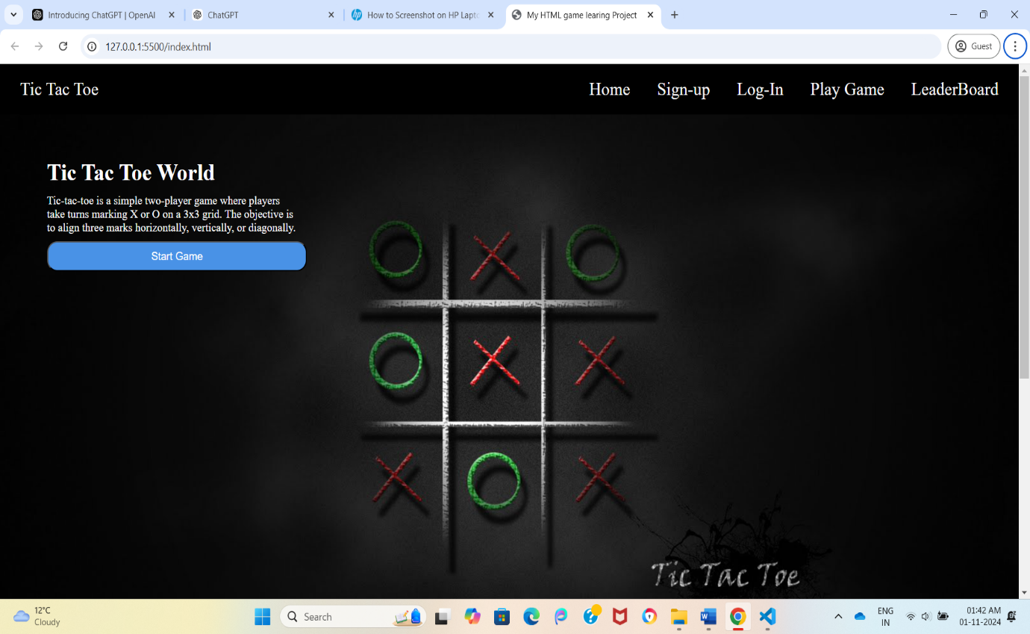
Fig 1: Home Page

This is home page of website. Which has navbar, footer, and body of the page. Then its has about us section down to it. There is Image background in background.

Fig2: navbar

This is Navbar of this Gameing website.

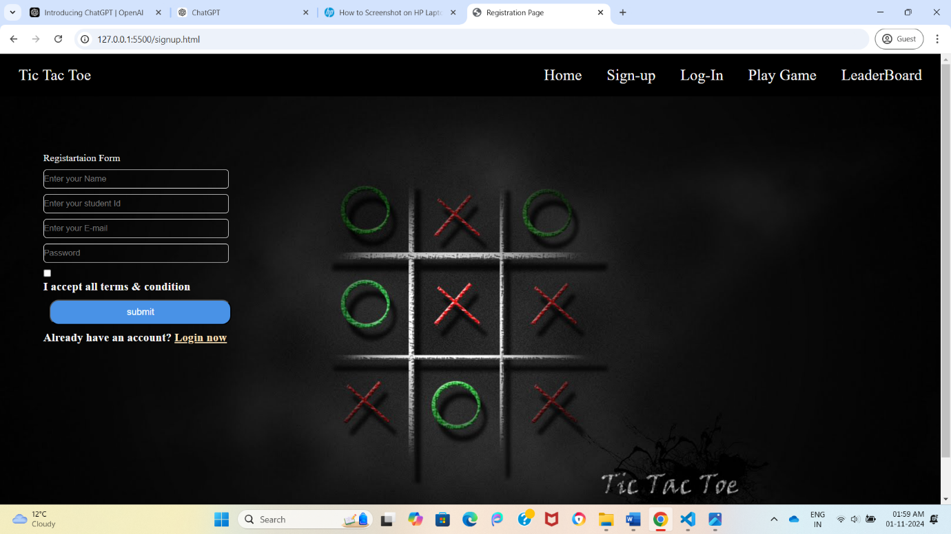
Fig3:Sigup page

This is Signup Page where user can register in localstorage via fullfing the fields.

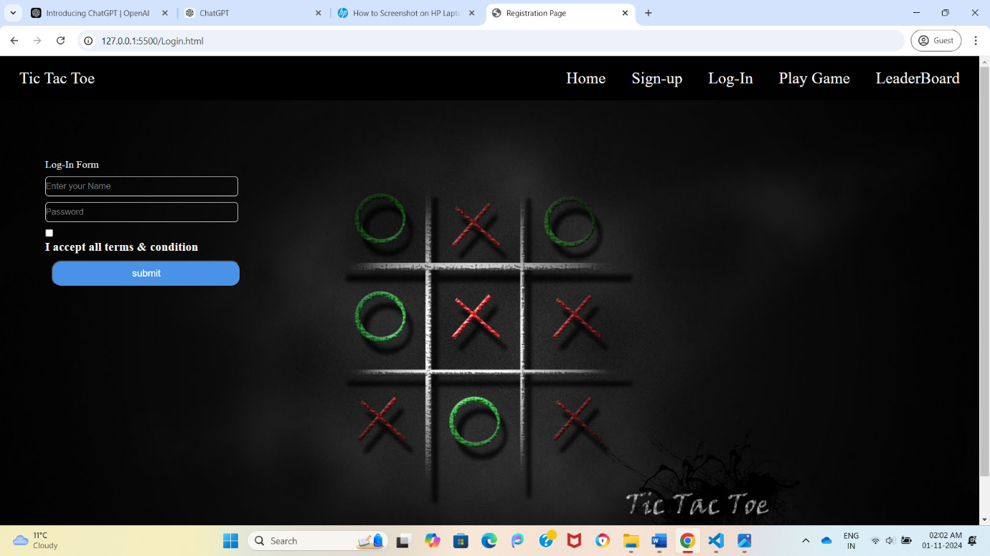
Fig4:Loginpage
This is Login page where user information get check for login.

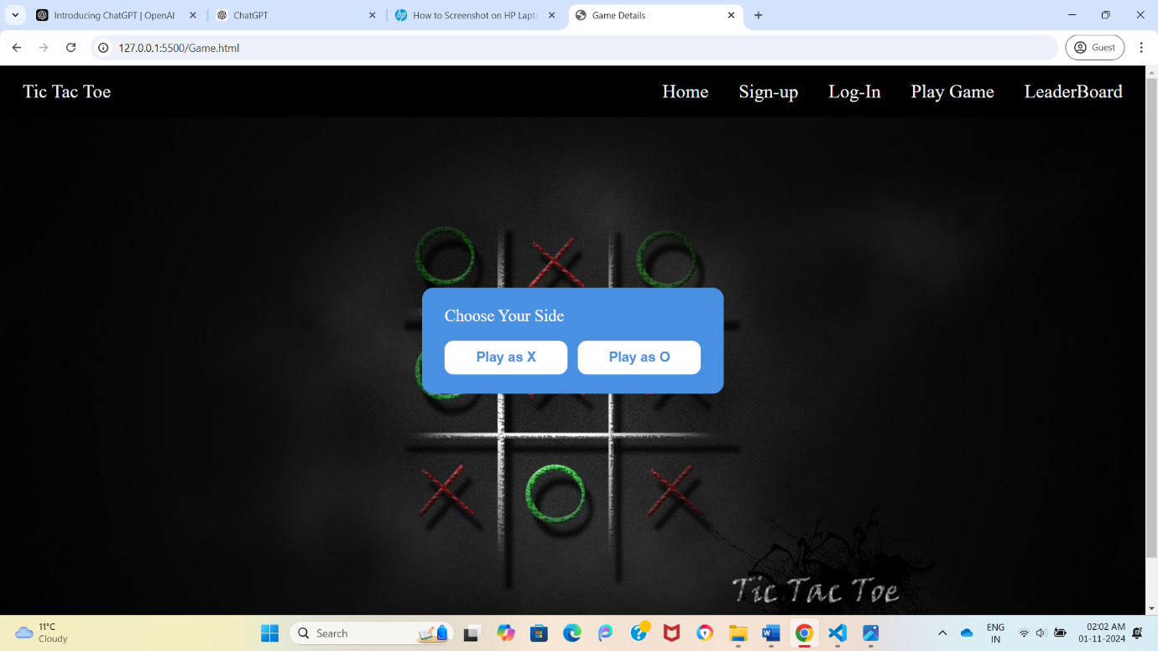
Fig5:GamePage

This is game where user come to play a game

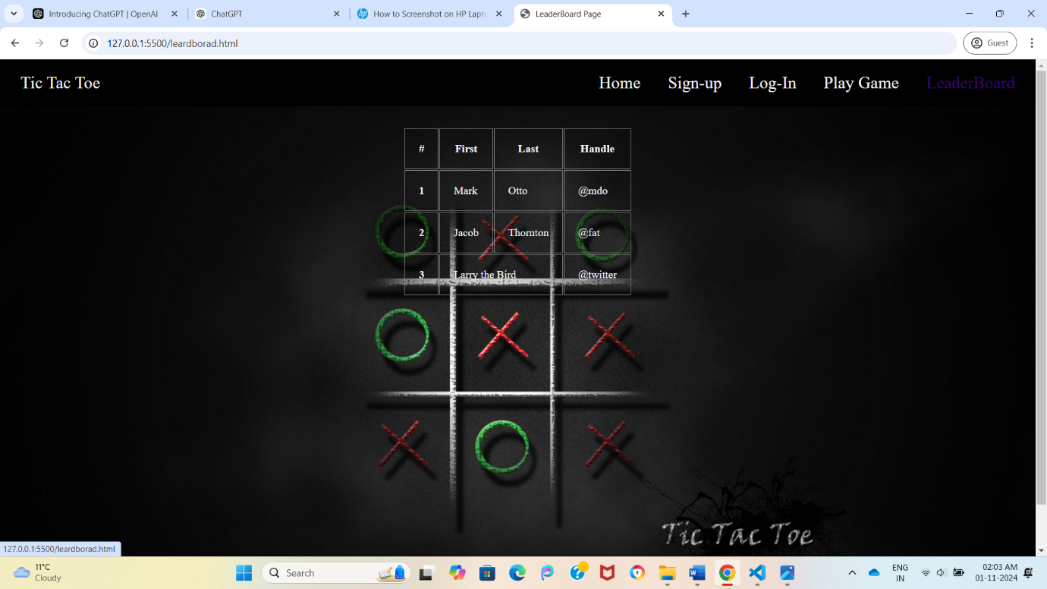
Fig6:TablePage
This is table page where user scores and data will show

- Flow of Website
First, User visits game website at homepage.
Second, user get registered in localstorage via filling the form an submit it.
Third, user go to login page to login from his creadtiles.
Fourth The game interface appers, allowing users to select their player type and start the game.
Lastly, winner get introduced

- Conclusion
This project demonstrates fundamental web development skills using HTML, CSS, and JavaScript. It provides an engaging user experience through interactive gameplay and user management features. Future enhancements could include additional game modes, improved styling, and more advanced AI for the bot.

